- SQL query !=
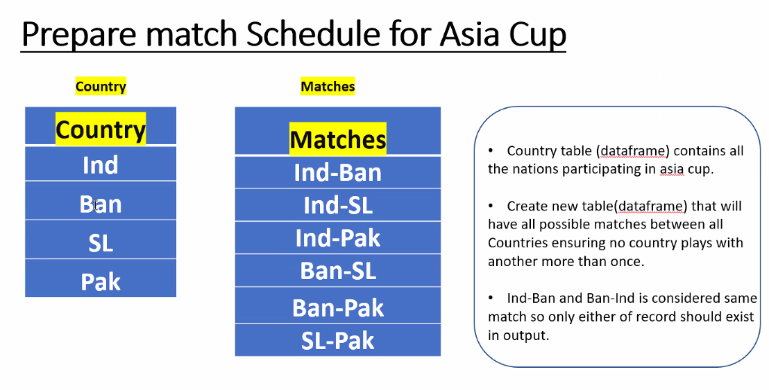

Achieve Matches table with Country table
Ans:
select
a.country || '-' || b.country as matches
from country_list a
cross join (select * from country_list) b
on 1=1
where a.country > b.country

- Spark Stages
3. What are the high level KPIs’ recommended for OTC process.

